Saira Kousar

55503 –CS-04

WAD Lab #05 ( Class Practice)

Task#01

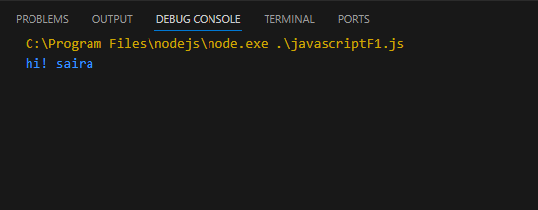

Task #02

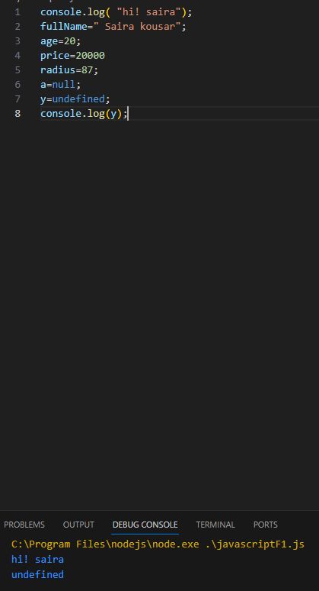

Task # 03

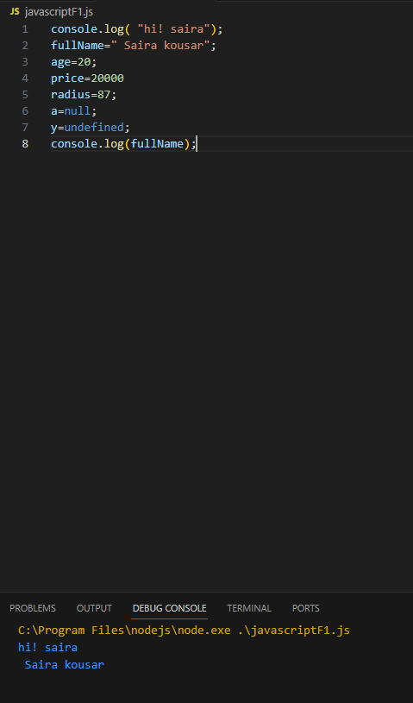

Task # 04

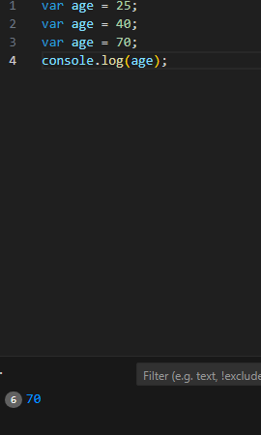

Task # 05

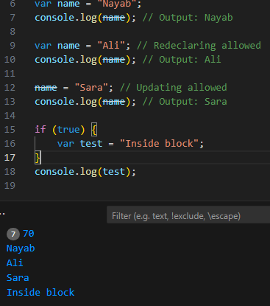

Task # 06

let fullName = "Saira";

console.log(typeof fullName);



Task # 07

 // Object creation

let person = {

    fullName: "Saira"

};

console.log(person);



Task # 08

let userAge = 25;

console.log(userAge);

userAge = 30;

console.log(userAge);

if (true) {

    let insideBlock = "Hello";

    console.log(insideBlock);

}

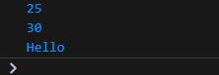

Task # 9

const pi = 3.1416;

console.log(pi);

// pi = 3.14; // Error: Assignment to constant variable

if (true) {

    const city = "Lahore";

    console.log(city);

}



Task # 10

let a = 10;

let b = 5;

console.log(a + b);

console.log(a - b);

console.log(a \* b);

console.log(a / b);

console.log(a % b);

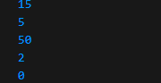

Task # 11

let score = 80;

if (score >= 50) {

    console.log("Pass");

} else {

    console.log("Fail");

}



Task # 12

For loop:

for (let i = 0; i < 5; i++) {

    console.log("Iteration: " + i);

}

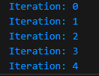

task # 13

let userName = "Nayab";

console.log("String:", userName);

let userAge2 = 25;

let piValue = 3.1416;

console.log("Number:", userAge2);

console.log("Float Number:", piValue);

let isGraduated = false;

console.log("Boolean:", isGraduated);

let emptyValue = null;

console.log("Null:", emptyValue);

let notAssigned;

console.log("Undefined:", notAssigned);

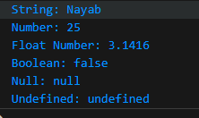

Task # 14

let studentScore = prompt("Enter the student score:");

if (studentScore >= 90) {

    console.log("Grade: A");

} else if (studentScore >= 80) {

    console.log("Grade: B");

} else if (studentScore >= 70) {

    console.log("Grade: C");

} else if (studentScore >= 60) {

    console.log("Grade: D");

} else {

    console.log("Grade: F");

}

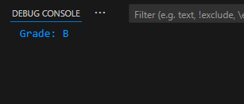

Task # 15

let number = prompt("Enter a number:");

if (number % 3 === 0) {

    console.log("Multiple of 3");

} else {

    console.log("Not a multiple of 3");

}



Task # 16

let x = 5;

console.log(x++);

console.log(++x);

console.log(x--);

console.log(--x);

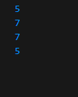

Task # 17

let time = prompt("Enter the time (0-24):");

switch (true) {

    case time >= 5 && time < 12:

        console.log("Morning");

        break;

    case time >= 12 && time < 18:

        console.log("Afternoon");

        break;

    case time >= 18 && time < 24:

        console.log("Evening");

        break;

    default:

        console.log("Night");

}



Task # 18

let num = prompt("Enter a number");

console.log("You entered:", num);

let student = { age: 20 };

console.log(student.age);

console.log(student["age"]);

student["name"] = "Rouman";

console.log(student);

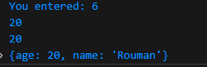

Task # 19

While loop:

let count = 0;

while (count < 5) {

    console.log("Count: " + count);

    count++;

}

